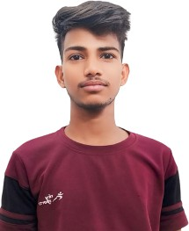
Resume
Name: Aman Phone: 8307754645
Email: AMANSEOSTAR@GMAIL.COM
Address: Umed Vihar Gali No. 3
Career Objective
- Self-motivated and hardworking fresher seeking for an opportunity to work in a challenging environment to prove my skills and utilize my knowledge & intelligence in the growth of the organization.
Academic Qualification

10th | HBSE | 2024 | 77.40% | 2nd
Professonal Qualification

Diploma | G.D UNIVERSITY | 2027 | 84% | 1ST
Extra Qualification
- Coding learner
Work Experience
- Hacking Learner
Personal Info
Dob : 08-02-2007
Father : Ram Avtar
Mother : Ram Devi
Nationality : Indian
Maritial_Status : Unmarried
Language : Hindi
Hobbies : Coding With Hacking

Declaration: I hereby declare that all the statement made in this resume are true, complete and correct to the Knowledge.
Date: (Aman)

